|  |
| --- |
| BOOKSHOP MANAGEMENT SYSYTEM |
| TRAVELS AGENCY |
| Project Documentation of DISM (Semester II) |

SHAHZINA KHAN

student 1074493

**Faculty** = Miss Aatika Liaquat

**Batch Code** = 1807E1

**Curriculum**= 6673

**Semester**= HDSE-Il

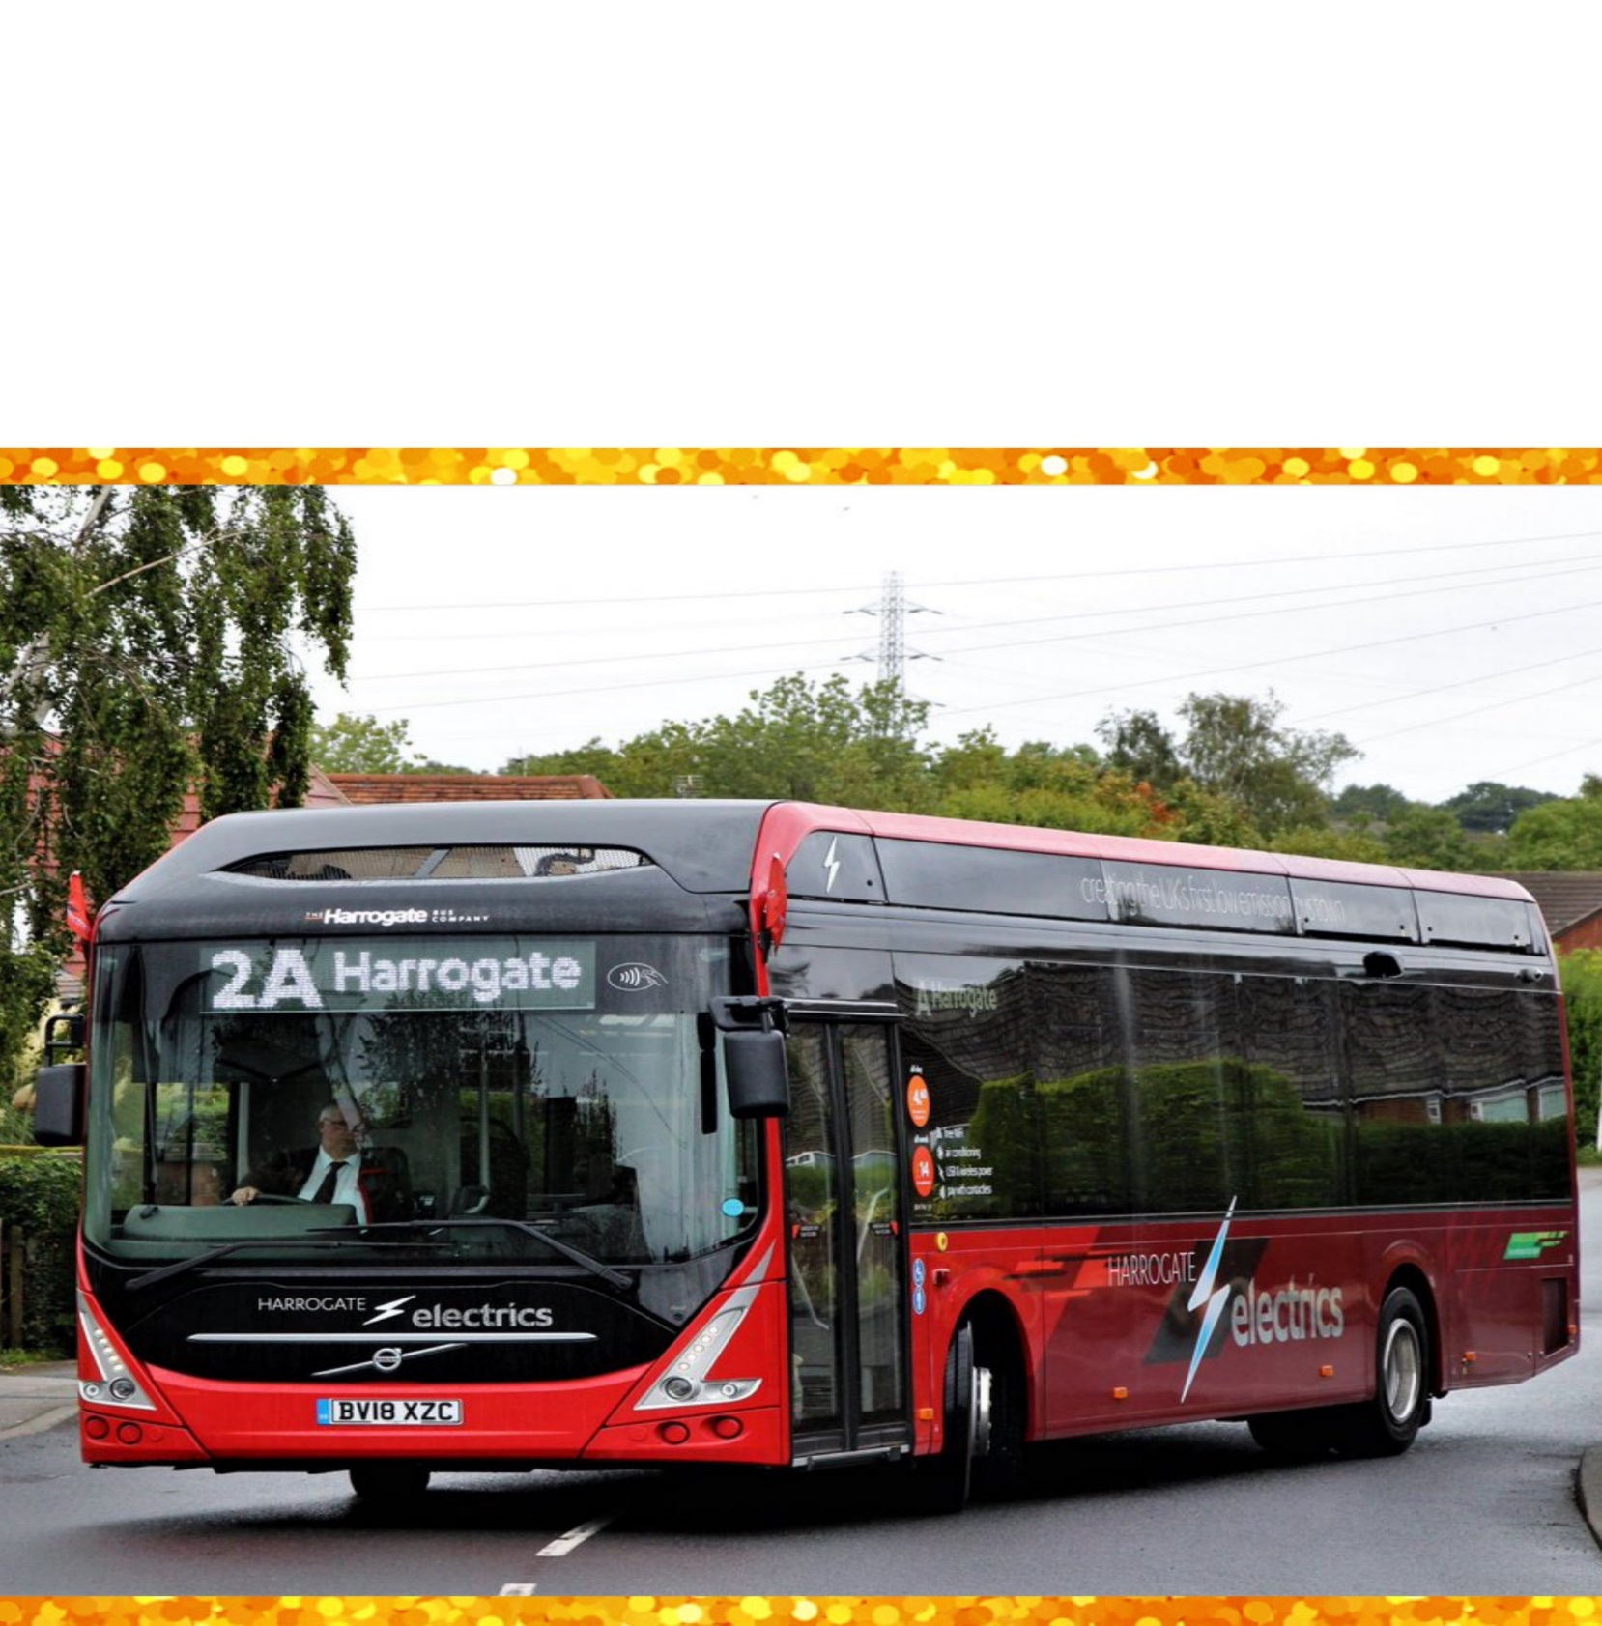**FRONTEND**

**FRONTEND**

**Login Page**

If user wants to book ticket or cancel it they need to login in first

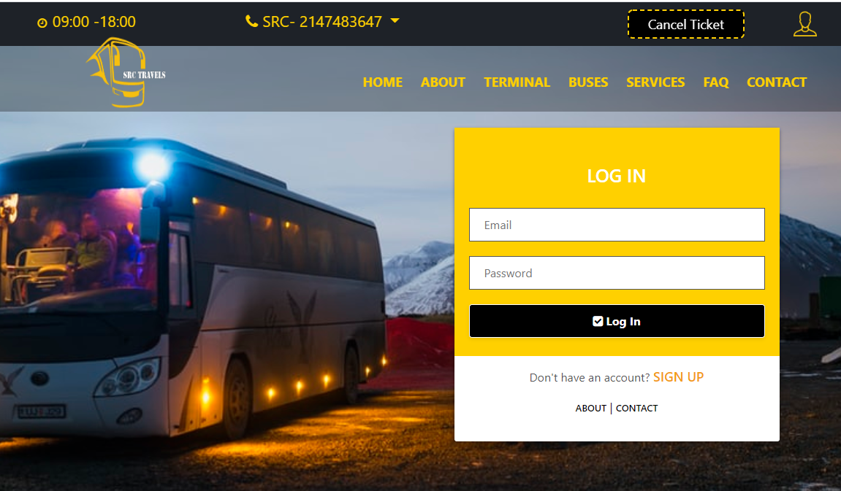

**Home Page**

This is the first page to be seen as website starts

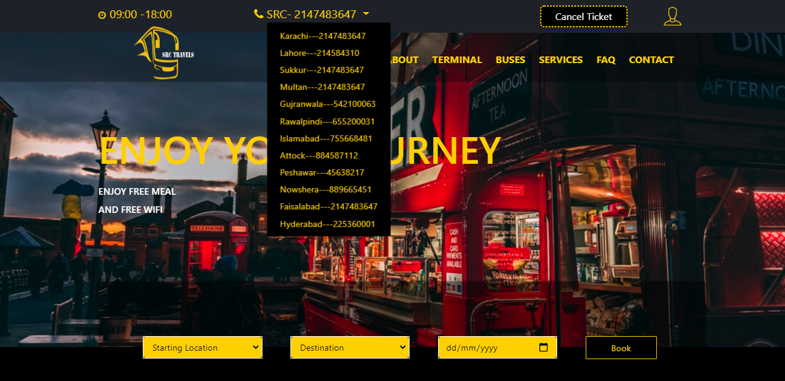

**About Page**

Here are a few lines about our travel agency

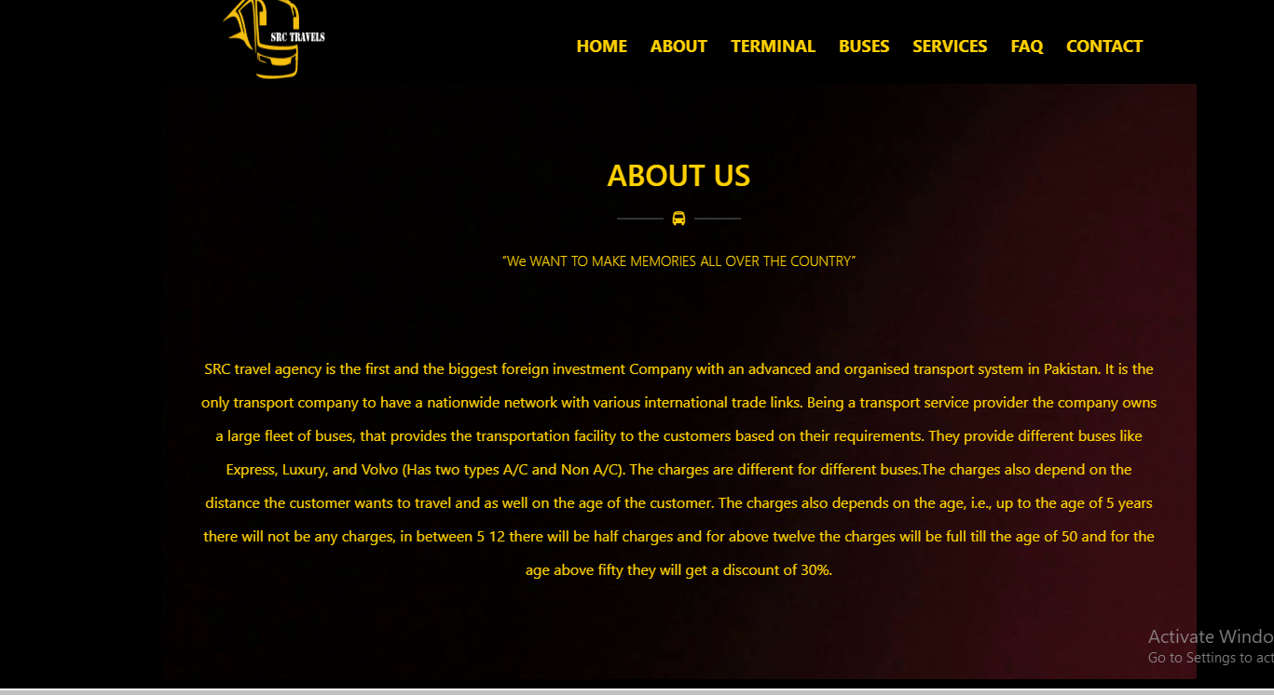

**Buses Page**

You can book here

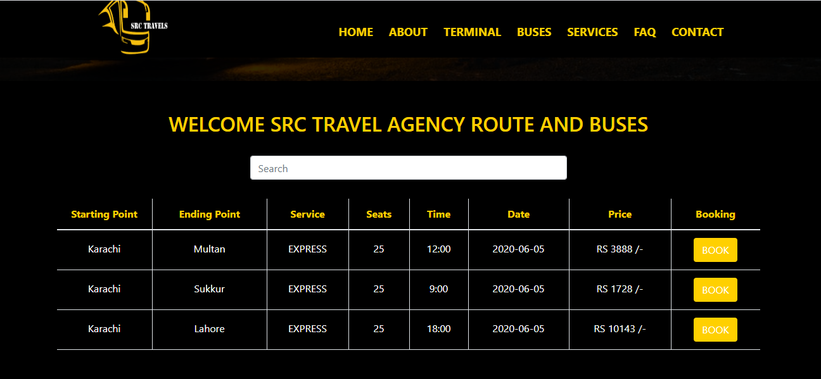

**Contact Page:-**

From this page customer can resolve quarries & can ask about services.

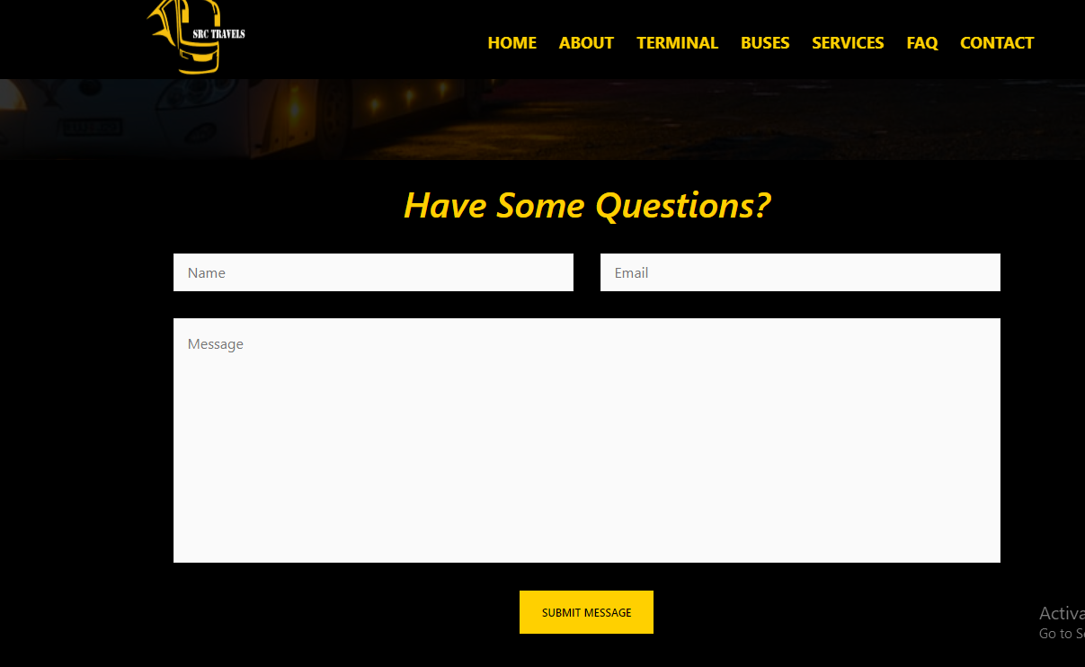

**Terminal Page:-**

This Page contain main terminal points details which are inserted in the database by the admin

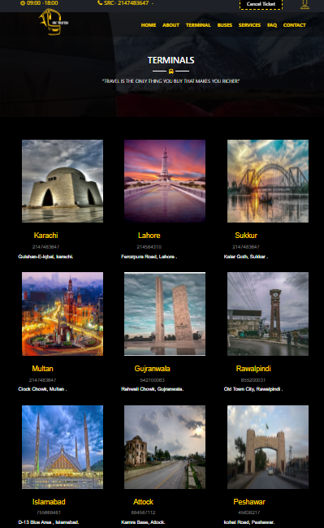

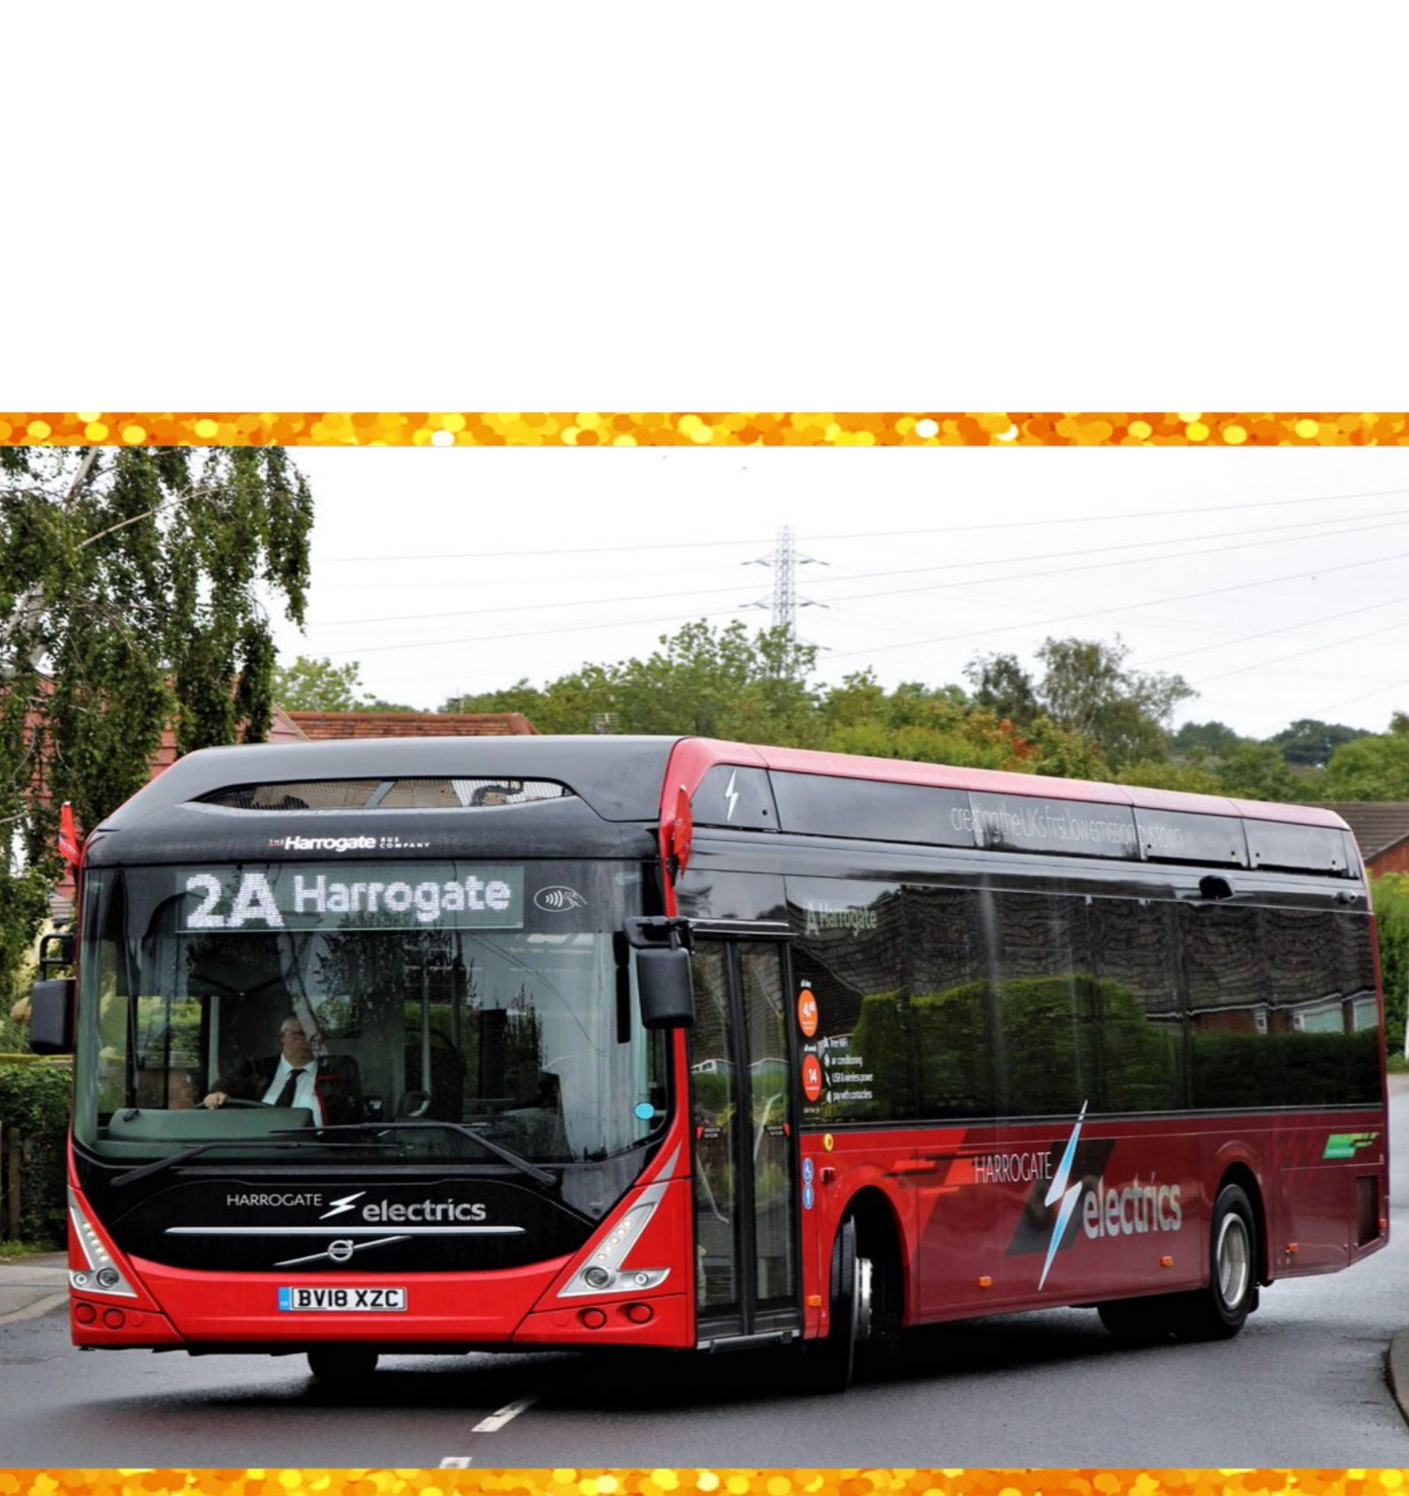

BACKEND

**BACKEND**

**Login Page**

This is the entry point of our application. First of all you’ll see this page then you can sign in through this and only if your id password matches with the id password in our data base you will proceed to next page .

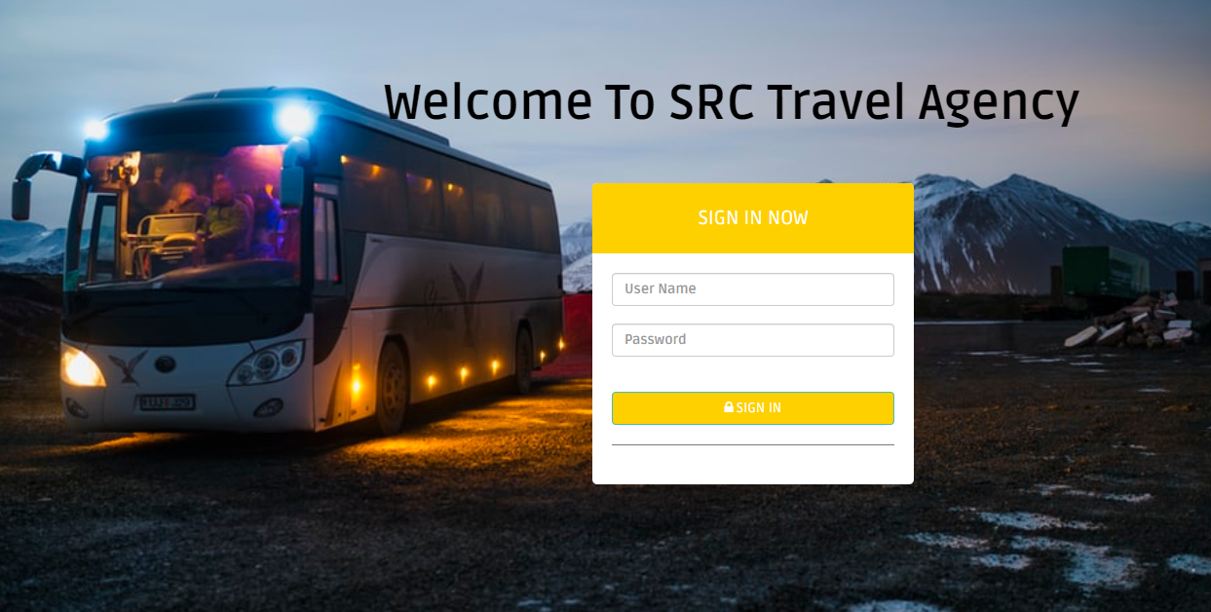

**Dashboard**

This is the dashboard from where admin can perform all the CRUD operations. Also can edit layout (Frontend) pages. Admin can see the enquiry box and will be able to respond them.

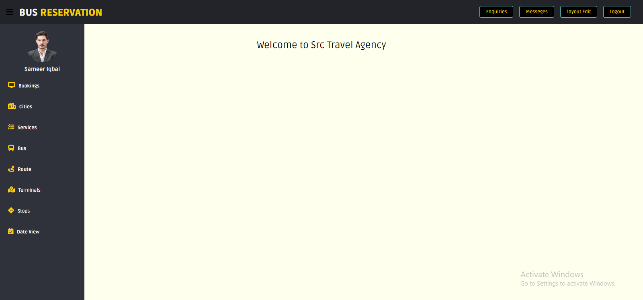

**Enquiry Read Page**

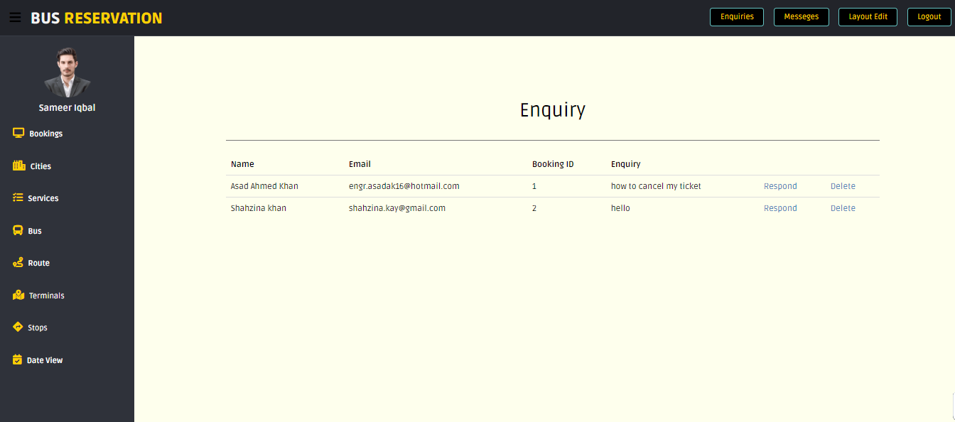

**Cities View Page**

Here admin can see all the cities where we have our terminals

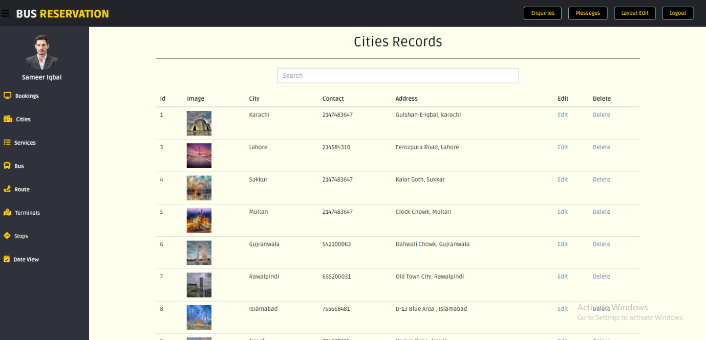

**Cities Insert Page**

Here adminstration can enter a new terminal

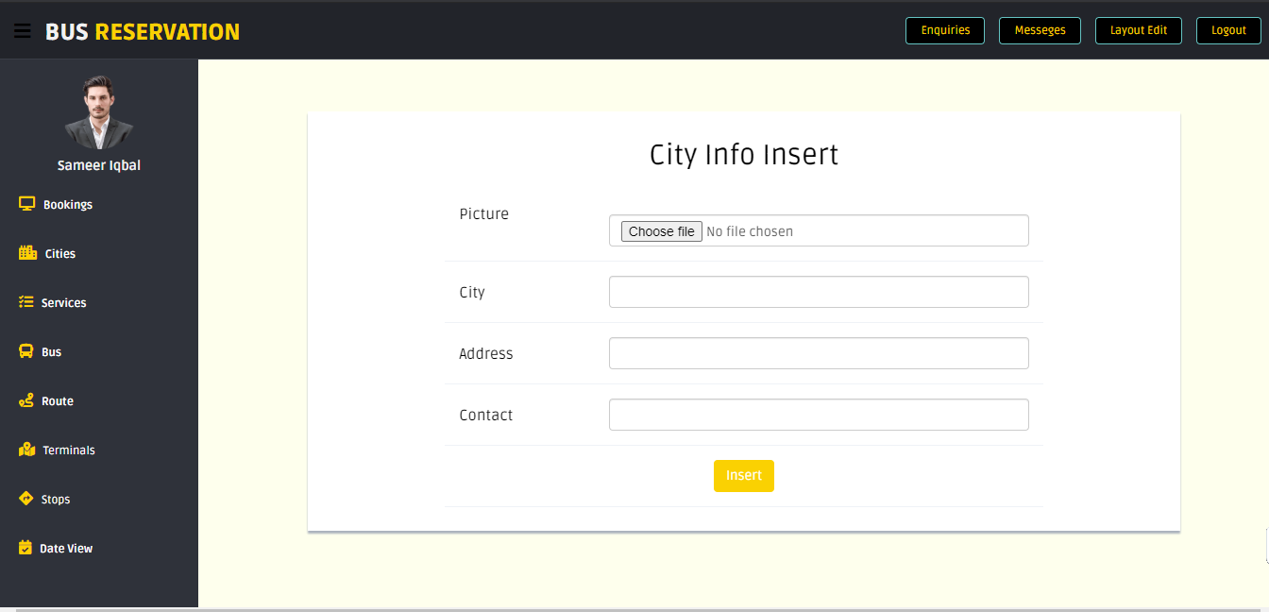

**Cities Update Page**

If adminsitration wishes to edit any details of the entered cites this the page like this every other entity has all crud pages.

